This document shows that the following graph generates a counterexample to Kempe’s 4 colour theorem: 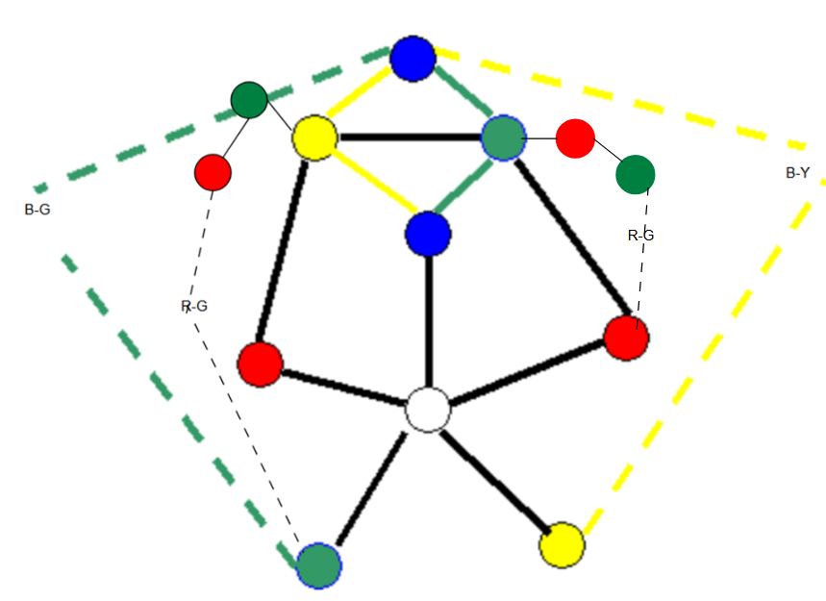

- The R-G Kempe chain on the left does not need to intersect the B-G kempe chain.

Heawood’s Counterexample from Shai Simonson:
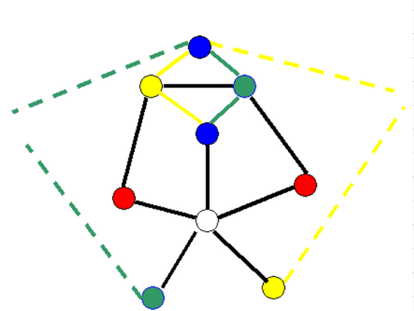

// Adjacency matrix (13 nodes, 18 edges)
// int adj[13][13] = {
{0, 1, 0, 1, 0, 0, 0, 0, 1, 0, 1, 0, 0},
{1, 0, 0, 0, 0, 0, 0, 0, 0, 0, 1, 1, 1},
{0, 0, 0, 0, 0, 1, 0, 0, 0, 1, 0, 0, 0},
{1, 0, 0, 0, 0, 0, 0, 0, 0, 1, 0, 0, 0},
{0, 0, 0, 0, 0, 0, 0, 0, 0, 1, 1, 0, 0},
{0, 0, 1, 0, 0, 0, 0, 0, 0, 0, 0, 1, 0},
{0, 0, 0, 0, 0, 0, 0, 1, 0, 0, 0, 0, 1},
{0, 0, 0, 0, 0, 0, 1, 0, 0, 1, 0, 0, 0},
{1, 0, 0, 0, 0, 0, 0, 0, 0, 1, 1, 0, 0},
{0, 0, 1, 1, 1, 0, 0, 1, 1, 0, 0, 0, 0},
{1, 1, 0, 0, 1, 0, 0, 0, 1, 0, 0, 0, 0},
{0, 1, 0, 0, 0, 1, 0, 0, 0, 0, 0, 0, 0},
{0, 1, 0, 0, 0, 0, 1, 0, 0, 0, 0, 0, 0}
// };

// Color sequence (13 nodes, 12 colored)
// 0=none 1=red 2=green 3=blue 4=yellow
// int colors[13] =
{2, 3, 4, 1, 1, 3, 3, 2, 3, 0, 4, 4, 2};


In our seminar, Heawood’s counterexample could be made 4-colourable with a coloring like the one below. The node on the right has a Green-Red-Yellow coloring in that chronological order.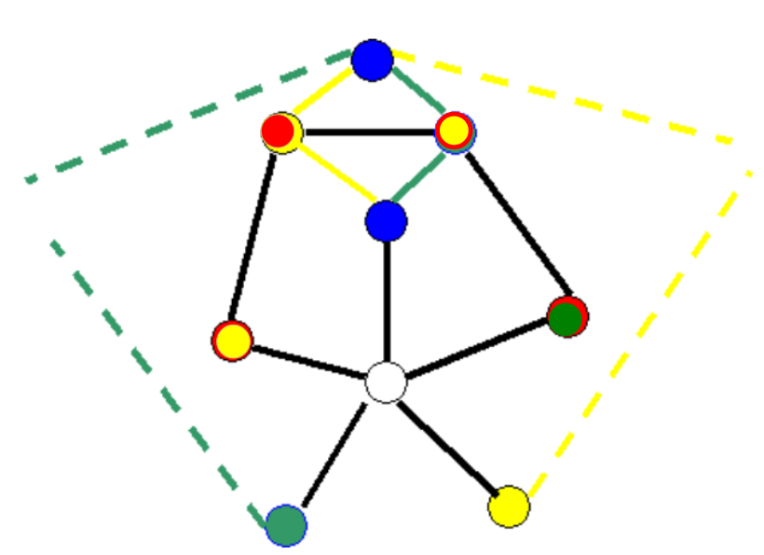

Forming a counterexample:

The process starts off from the beginning with the R-G Kempe chain on the left added. A counterexample will be eventually generated.

Assume an R-G Kempe chain connected from Y in the original graph. The R-G Kempe chain can intersect the B-G Kempe chain 0,1, or 2 times.
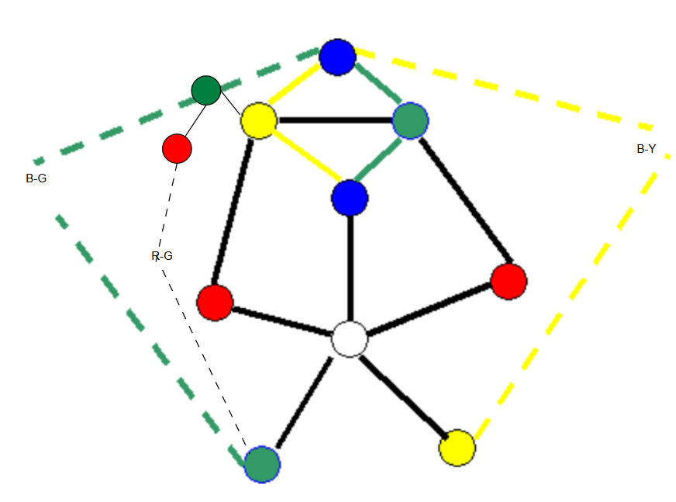

Begin from the original Kempe Method by toggling the two R-Y and R-G pairs.
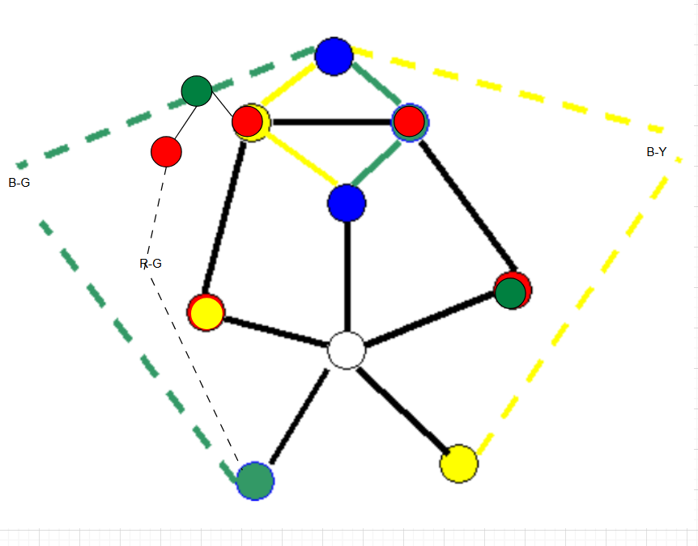
Toggle the R-G Kempe chain to remove the adjacent green coloured nodes.
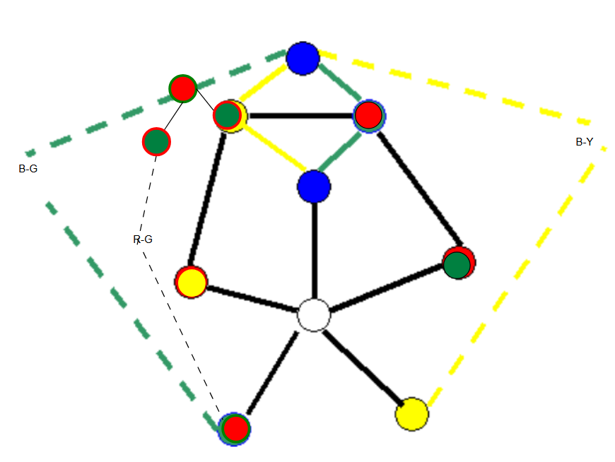

Assume an R-G Kempe chain was on the right side of the original graph as well.
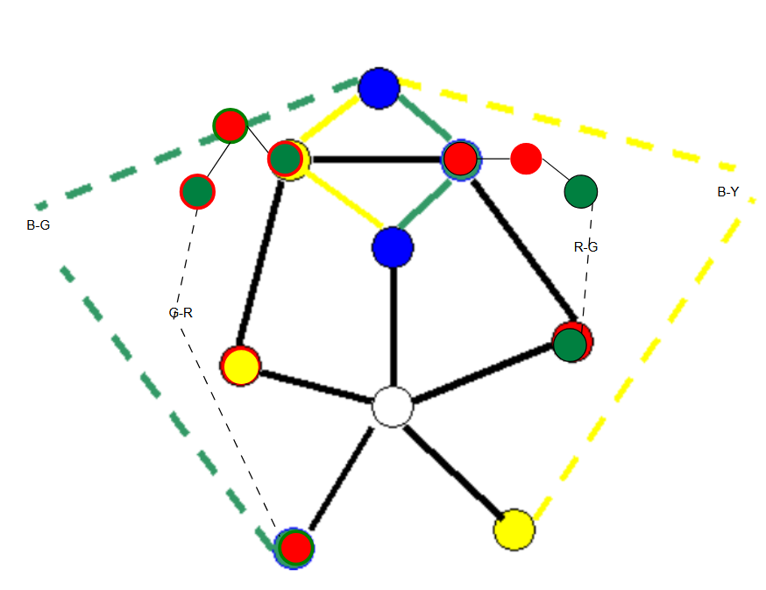
Toggle the added R-G network / Kempe chain, excluding the existing connected R-G nodes to make the adjacent nodes different coloured. The B-Y chain makes this possible. The R-G Kempe chain on the left is now made simplified.
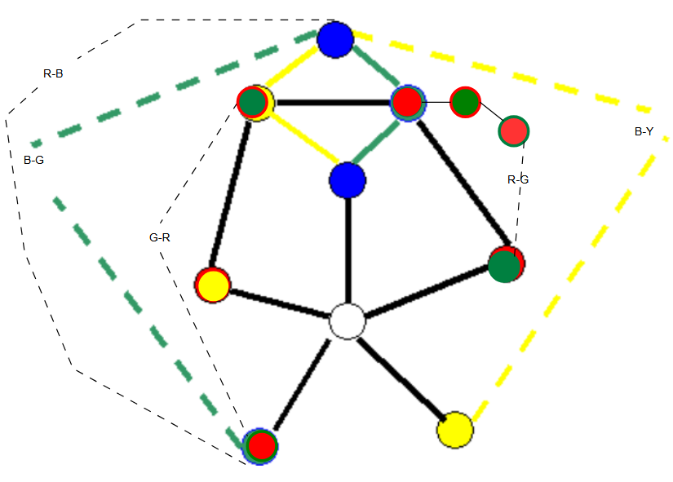
If R was connected to a RG kempe chain.
This results in all the neighbours of the uncoloured node still being all 4 colours. Where we left off in the seminar.

Following Kempe’s method again:
1)
- Attempt to make the bottom left red node Blue. This fails due to a potential R-B Kempe chain (newly added).
- Attempt to make the bottom left red node Green. This fails due to R-G Kempe chains.


- The second attempt is to change the double colouring, i.e. two yellows.
The bottom right yellow can be toggled to blue. There is no B-Y Kempe chain because the G-R Kempe chain on the left blocks off any possible B-Y Kempe chain. A B-Y Kempe chain can enter until blocked off by the G-R Kempe chain.
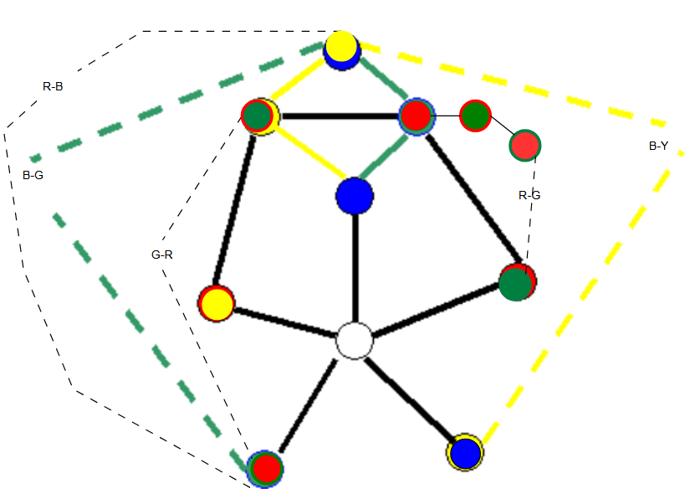
The left yellow can not be toggled to green. There can be a G-Y Kempe chain (added) as shown:
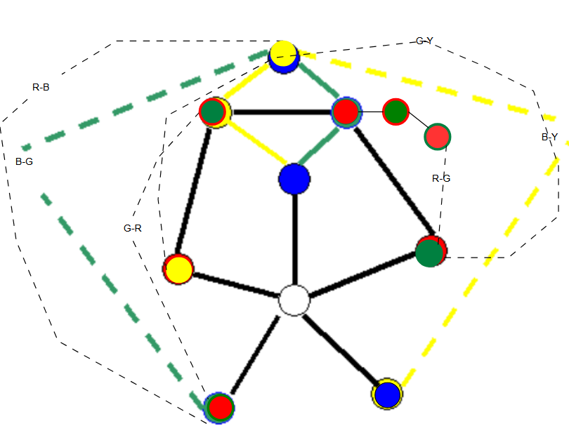
The G-Y Kempe chain is made clearer below. See the added yellow dotted line on the left. It goes through the Yellow-coloured node on top and through the (Y-)G-R Kempe chain on the left.
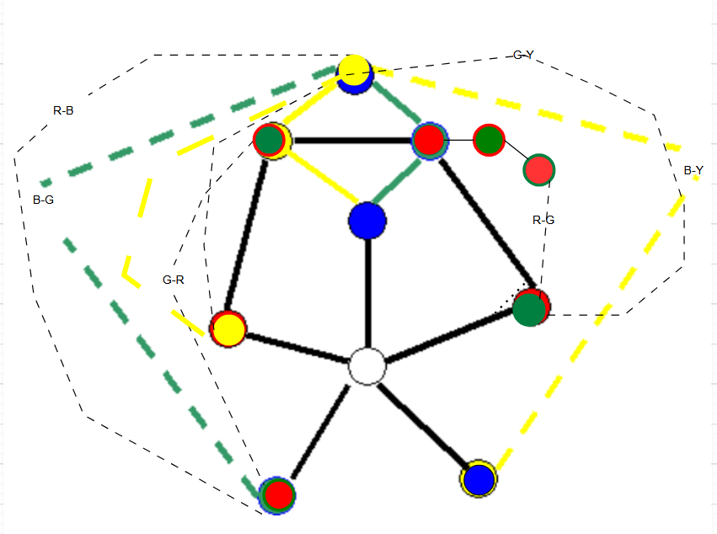

Kempe chains from 2-5. 2-5 toggling 3-5 works, then toggling 1-4 can’t work since a blue red kempe chain is now created. The top node on top changes so that it is blocked.

With this configuration (two blues, previously two yellows), there are:
- G-Y Kempe chain (2-5)
- R-G Kempe chain (2-4)
- B-Y Kempe chain (3-5)
There is no B-R Kempe chain (1-4), due to the Y-node on top, but since there are 3 Kempe chains, any recolouring, will still result in 3 Kempe chains. Any recolouring will generate another double colouring with the same 3 Kempe chains that don’t allow Kempe’s method to work.

Conjecture: any node with 5 neighbours with more than 2 Kempe chains between two pairwise different neighbours is not 4 colourable.


So the counterexample originates from a graph like this:

to form a graph like this (unofficial):
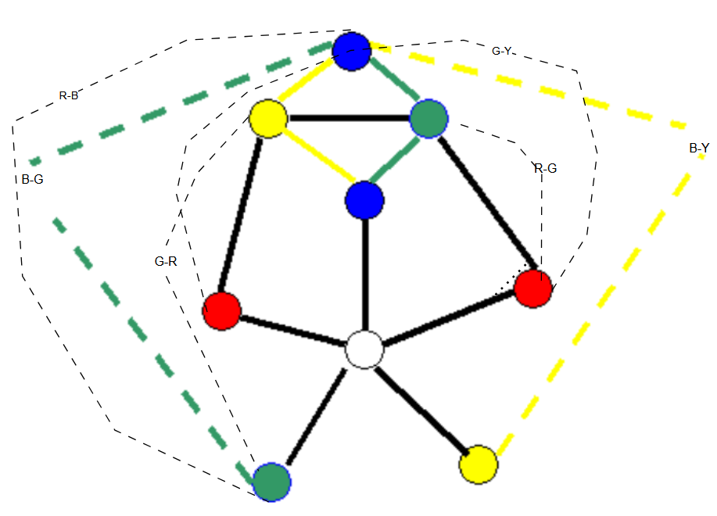

Second counterexample:
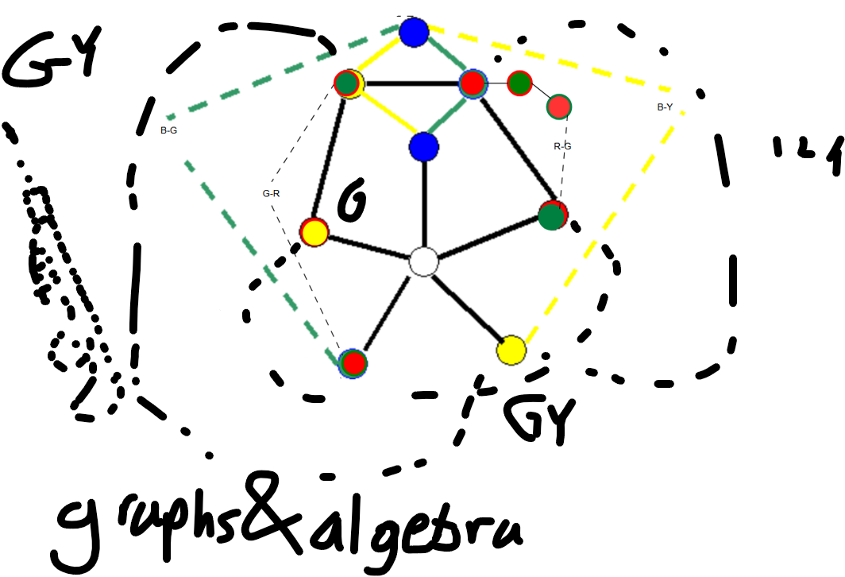
This counter example will not be illustrated much.
G-R R-G kempe chains as shown. G-Y kempe chain from G-Y in pentagon. Y connected to R and G. If G-Y kempe chain needs to be toggled to ensure proper coloring, then there will be a double colloring in G-y DUE TO the added edges.

